MT103 PAYMENT INSTRUCTIONS(匯入款指示)
57D: Please Remit Value to Our Bank(請匯入我的往來銀行):
MEGA INTERNATIONAL COMMERCIAL BAND
SOUTH TAICHUNG BRANCH
257. WU CHUAN W. RD. SEC1, TAICHUNG 403, TAIWAN
SWIFT: ICBCTWTP044

59: OUR A/C & NAME(我的帳號)
A/C NO: 044-53-05098-6
A/C NAME: Taiwan Tati Cultural and Educational Foundation
TEL(電話): 886-4-23723710
AMOUNT(匯款金額):

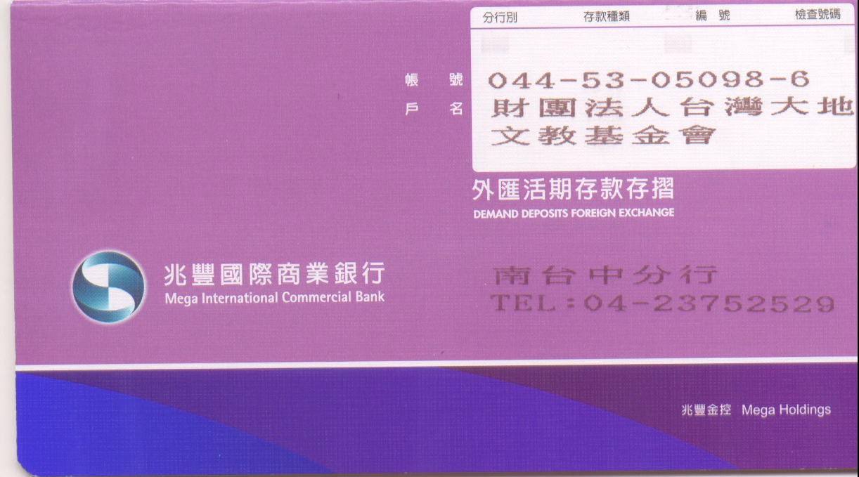
THE COVER FUNDS credit the following correspondent bank by MT202(可經由下列銀行轉帳):

USD: SWIFT: | ICBCUS33  PNBPUS3NNYC  BKTRUS33  BOFAUS6S  CHASUS33  IRVTUS3N  ABNAUS33 |  | GBP: SWIFT: | MIDLGB22  NWBKGB2L  BARCGB22
EUR: SWIFT: | ICBCNL2A  ICBCFRPP  COBADEFF  DEUTDEFF  BCITITMM |  | AUD: SWIFT: | ICBCAU2S  ANZBAU3M  NATAAU33033  WPACAU2S
HKD: SWIFT: | ICBCHKHH  SCBKHKHH  HSBCHKHHHKH |  | NZD: SWIFT: | BKNZNZ22985  ASBBNZ2A
JPY: SWIFT: | ICBCJPTJ  BOTKJPJT |  | CAD: SWIFT: | ICBCCATT
 |  |  | NGD: SWIFT: | BKNZNZ22985  ASBBNZ2A
 |  |  | CAD: SWIFT: | ICBCCATT
 |  |  | SGD: SWIFT: | ICBCSGSG
 |  |  | THE: SWIFT: | ICBCTHBK

(其他幣別請向兆豐國際商業銀行南台中分行查詢，886-4-23752529)

